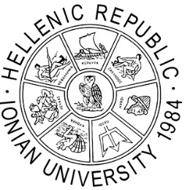

IONIAN UNIVERSITY

LIFELONG LEARNING CENTER - IONIAN UNIVERSITY

Status of Trainees
who attended and successfully completed the Lifelong Learning Course

Lifelong Learning Course Title: ………………………………………………………………………………………………………………

ELKE Project Code: ………………………………… Implementation period: (…./…./…… - …./…./……)

Scientific Coordinator: …………………………………………………………………………………………………………..

Α/Α | Surname | Name | Telephone | Address | City | postal code | e-mail | Educational Grade * | Age Group **

* Compulsory Education / Secondary Education / University Education / Postgraduate Degree / Doctoral Degree
**18-24 / 25-34 / 35-44 / 45-54 / 5564 / 65+

Scientific Coordinator
of the Course

(Signature / Full Name)

The list with the names of the trainees who attended and successfully completed the Course is forwarded by the Scientific Coordinator to the Secretariat of Lifelong Learning Centre – Ionian University upon completion of the Lifelong Learning Course.

