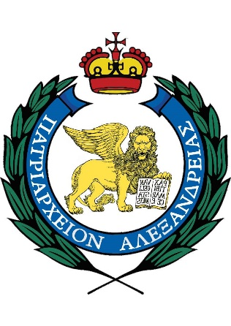
Patriarchate of Alexandria and All Africa
Holy Orthodox Archdiocese of Accra, Ghana

St. Cyril’s Lucaris Orthodox Theological and Cultural School
********

Registration application

NAME:

SURNAME:

FATHER’S NAME:

MOTHER’S NAME:

DATE OF BIRTH:

PASSPORT ID OR GHANA CARD:

ΝΑTIONALITY:
ORIENTATION: Male / Female
PRIOR EDUCATION:

ADDRESS:
Ε – ΜΑΙL:
Tel. number:
: / /2025

