
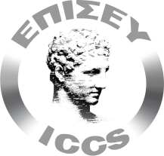

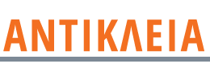
International conference
"Final conference on infrastructures and applications that use and exploit cultural content"
Ionian University invites all interested parties to participate in the final conference of the ANTIKLEIA project, which will take place on January 14, 2022 as a fully virtual online event. ANTIKLEIA project, fully entitled "Development of technologies and methods for interoperability of cultural heritage data - ANTIKLEIA" is co-funded by the European Union (European Regional Development Fund - ERDF) and national resources, under the action "RESEARCH-CREATE-INNOVATE" of the Operational Programme "Competitiveness-Enterprise and Innovation" and is implemented by the partnership of two research organisations, the Institute of Communication and Computer Systems (ICCS-NTUA) and the Department of Informatics of the Ionian University, in collaboration with a high-tech and innovative company, Soliddop.
The main actions of the ANTIKLEIA project included the creation of a digital platform and tools for the creative re-use of cultural content and the support of interoperability of metadata.
The digital portal of the project is a fundamental tool for the implementation of its actions, including its cultural, economic and social aspects, and can be considered as a pool of links to the main activities and actions carried out throughout the project.
More information is available on the platform's website https://antikleia.gr/ .
Online event available at:
https://ionio-gr.zoom.us/j/92365585955?pwd=OVc5Tlg4SGFoUUY3VFBFeG1tOWx2Zz09

