 | 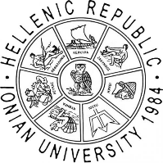

Erasmus+ Blended Intensive Programme (BIP)

Sustainable Destination Management & Marketing
Department of Tourism, Ionian University, Corfu, Greece | 13–17 October 2025

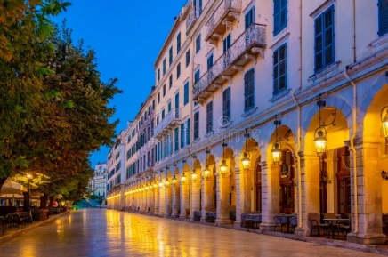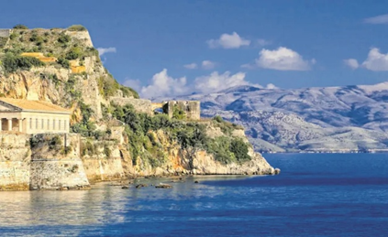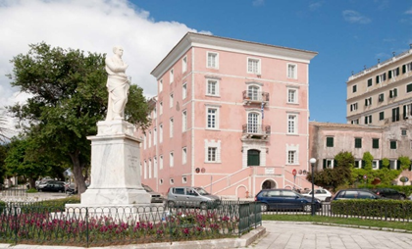

✨ Join us for a unique academic journey!
Discover how destinations can be managed and marketed sustainably — in one of the most iconic Mediterranean islands.

👉 Why join?
- Learn from international experts in tourism & sustainability
- Combine preparation with real-life study visits in Corfu
- Work in multicultural teams on case studies

Programme Highlights
- Online sessions (before the on-site): fundamentals of sustainable tourism
- On-site week in Corfu (13th -17th Sept 2025): workshops, case studies, field visits
- International teamwork: case study on sustainable destination development
- Final online presentations (30 October 2025): project outcomes & feedback

Coordinators
Naoum Mylonas – Assistant Professor, Department of Tourism, Ionian University, Email: nmylonas@ionio.gr
Christina Beneki – Professor, Department of Tourism, Ionian University,
Email: benekic@ionio.gr

Participating Institutions
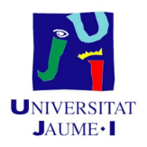 | 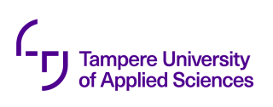 |  | 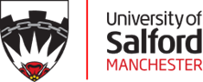 | 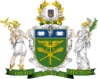  ukraine’s NATIONAL UNIVERSITY OF TRADE AND ECONOMICS

